Java OOPs Concepts

1. [Object Oriented Programming](https://www.javatpoint.com/java-oops-concepts#oops)
2. [Advantage of OOPs over Procedure-oriented programming language](https://www.javatpoint.com/java-oops-concepts#oopsadvantage)
3. [Difference between Objcet-oriented and Objcet-based programming language.](https://www.javatpoint.com/java-oops-concepts#oopsdifference)

**Simula** is considered as the first object-oriented programming language. The programming paradigm where everything is represented as an object, is known as truly object-oriented programming language.

**Smalltalk** is considered as the first truly object-oriented programming language.

OOPs (Object Oriented Programming System)

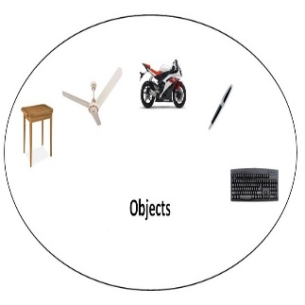

**Object** means a *real word entity* such as pen, chair, table etc. **Object-Oriented Programming** is a methodology or paradigm to design a program using classes and objects. It simplifies the software development and maintenance by providing some concepts:

* Object
* Class
* **Inheritance** (superclass, subClass)
* **Polymorphism** (use Parent class ref variable to refer child class object)
* **Abstraction** (is achieved using abstract class or Interface)
* **Encapsulation** (binding data with its functions together – private variables , public methods to access those variables)

Object-oriented programming (OOP) is a programming language model organized around [objects](http://searchsoa.techtarget.com/definition/object) rather than "actions" and data rather than logic.

Object –

It is an instance of class - Object is real world entity that has state and behavior is known as an object. For example: chair, pen, table, keyboard, bike etc. It can be physical and logical.

Class

**Collection of objects** is called class. It is a logical entity.

Class is a way to bind the data and its associated functions together.

Inheritance

**When one object acquires all the properties and behaviors of parent object** i.e. known as inheritance. It provides code reusability. It is used to achieve runtime polymorphism.

Inheritance means a mechanism of deriving a new class from old one. It is nothing but reusability of already defined and compiled class.

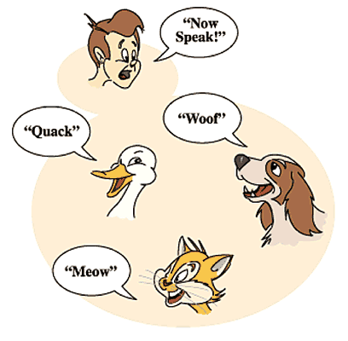

Polymorphism

When **one task is performed by different ways** i.e. known as polymorphism. For example: to convince the customer differently, to draw something e.g. shape or rectangle etc.

In java, we use method overloading and method overriding to achieve polymorphism.

Another example can be to speak something e.g. cat speaks meaw, dog barks woof etc.

Polymorphism means use the PARENT class reference variable to refer child class objects.

Abstraction

**Hiding internal details and showing functionality** is known as abstraction. For example: phone call, we don't know the internal processing.

Abstraction means providing only essential details to outside world and hiding their background details.

In java, we use abstract class and interface to achieve abstraction.



Encapsulation

**Binding (or wrapping) code and data together into a single unit is known as encapsulation**. For example: capsule, it is wrapped with different medicines.

“Binding of data and function together into a single class-type variable is called as encapsulation”

A java class is the example of encapsulation. Java bean is the fully encapsulated class because all the data members are private here.

|  |  |
| --- | --- |
|  |  |

What is difference between object-oriented programming language and object-based programming language?

Object based programming language follows all the features of OOPs except Inheritance. JavaScript and VBScript are examples of object based programming languages.